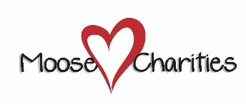
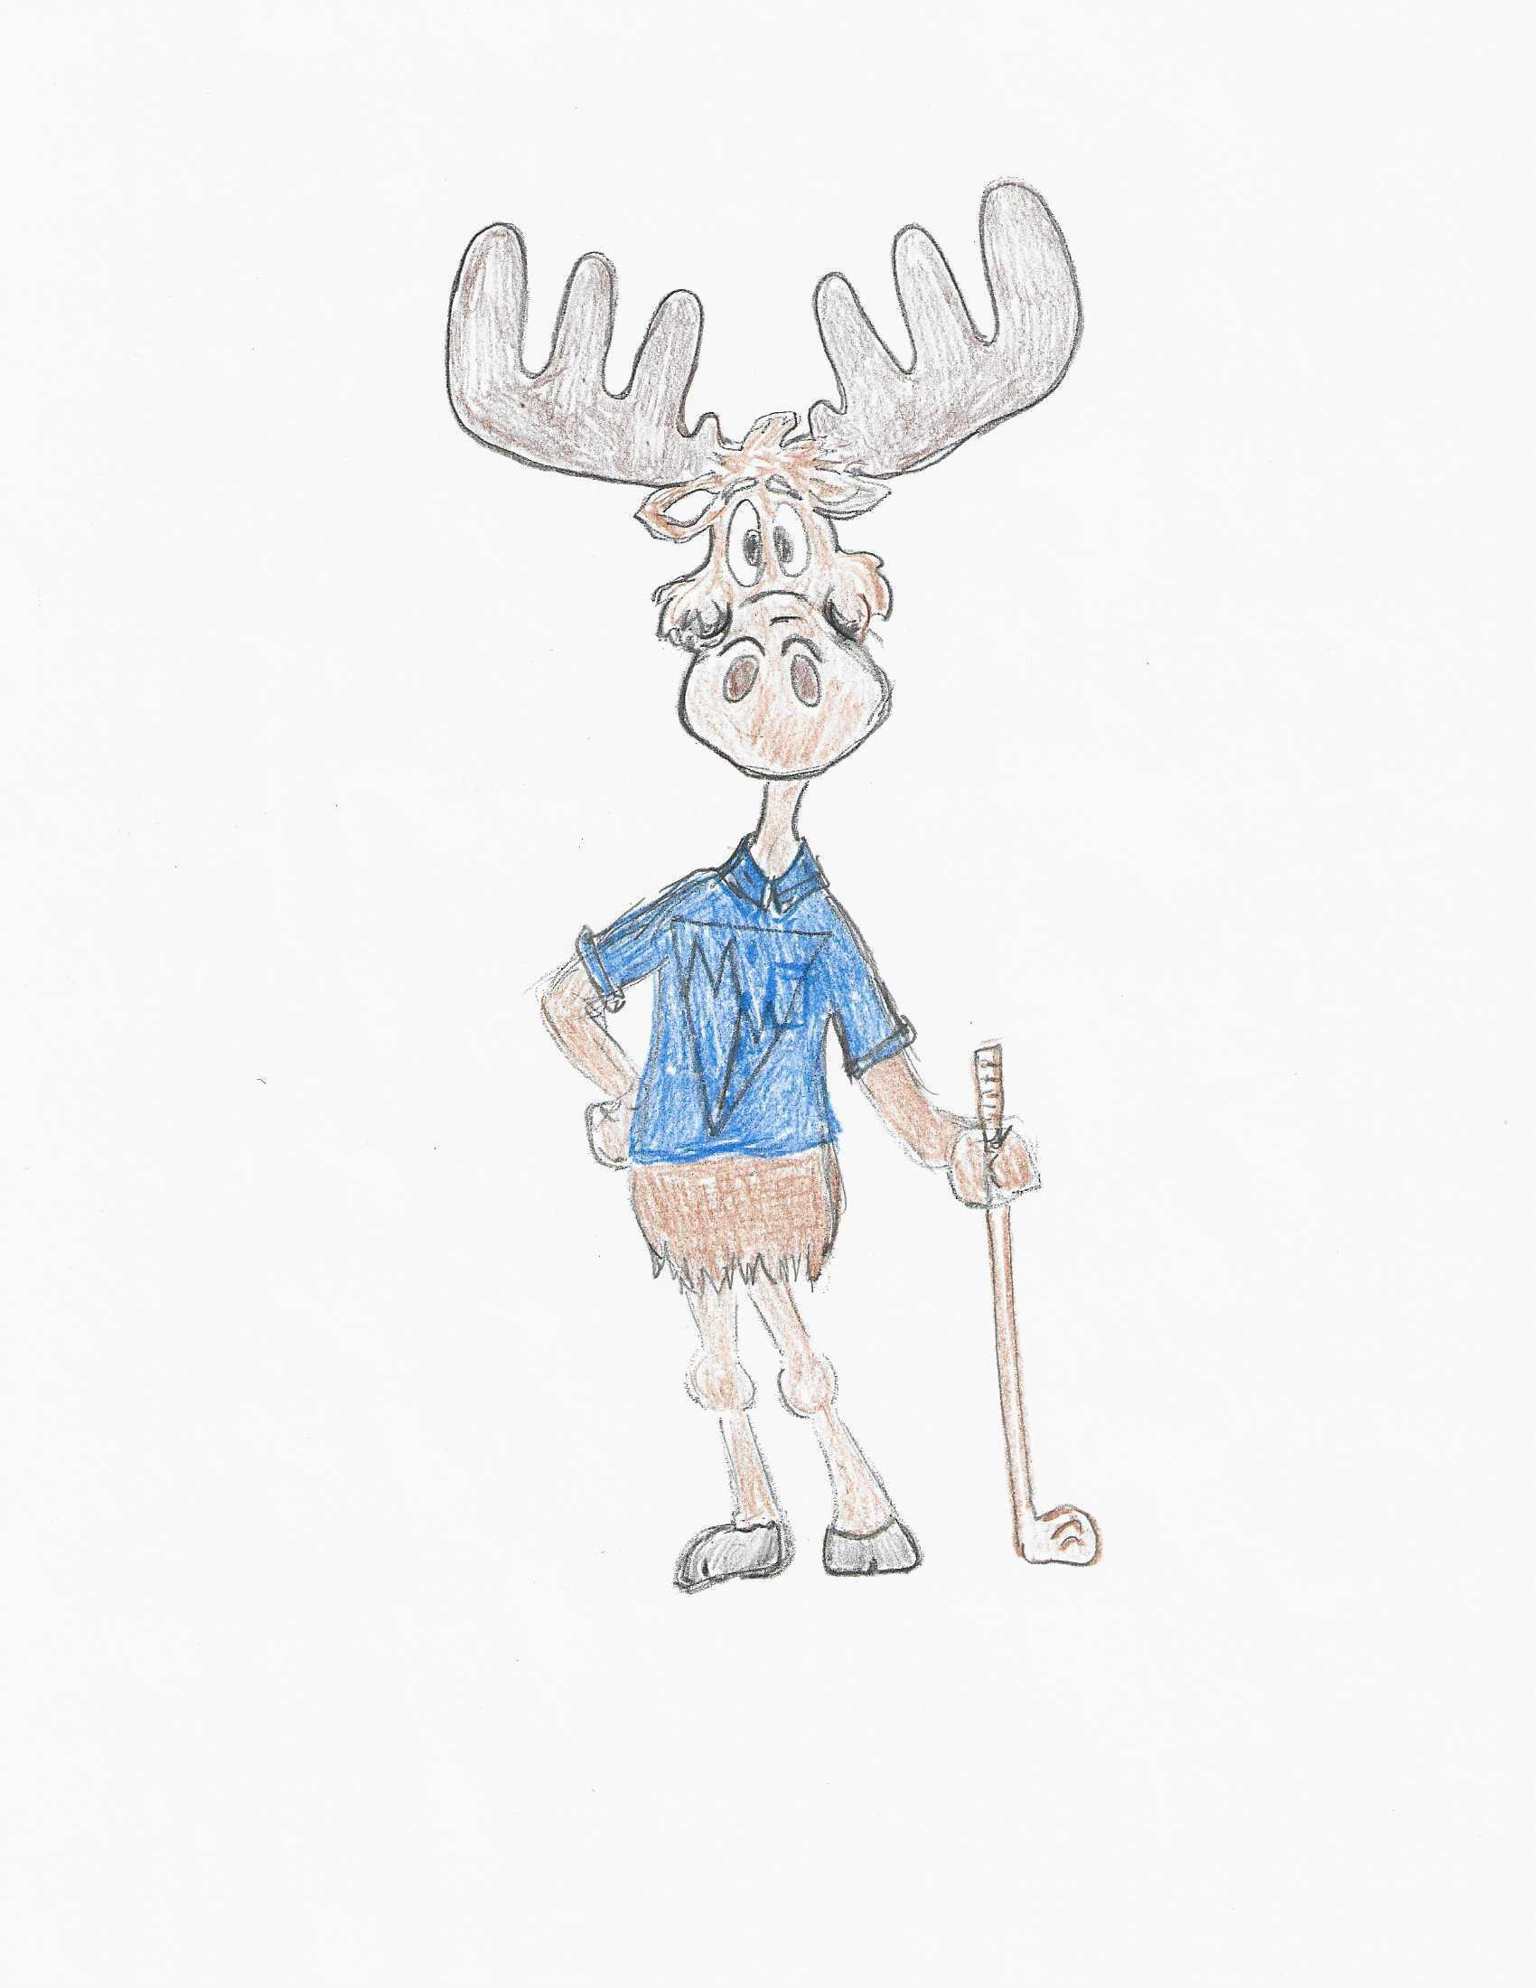

Making a difference in the lives of children and seniors

RELEASE FORM
Event – Kennewick Moose, Lodge Legion Fundraising Golf Tournament
Hosted by the Lodge Legion Committee
Event Date: June 3, 2023 Location: West Richland Golf Course
The undersigned, herin referenced, apply to enter the event indicated above.
In consideration of the acceptance of my (our) application to enter this event, I hereby waive, release, and discharge any and all claims for damages, death, personal injury, or property damage, which I (we) may have, or which may subsequently occur to me (us) as a result of my (our) participation This Release is intended to discharge the, Loyal Order of Moose, any State or Provincial Moose Association and/or any sponsoring Lodge(s), their respective agent(s) and employee(s) from and against any and all liability arising out of, or connected in any way with my (our) participation in this event, even though liability may arise out of negligence or carelessness on the part of the person(s) or entity(s) mentioned above.
The terms hereof shall serve as a release and assumption of risk for my self, team, or associated persons in exchange for my participation in this event.
I (we) the undersigned, attest and affirm that I (we) have read, understand and agree with the rules of this event and agree to abide by said rules and the above statement. I (we) also affirm that the statements set forth above are true and correct.

PARTICIPANTS SIGNATURE | DATE | MEMBER | GUEST
Team Captain

PLEASE MAKE CHECKS PAYABLE TO: MOOSE LODGE

